Test Case Id: 03 |  | Test Purpose: User can change the language on the site to Spanish
Environment: Cypress 5.2.0
Preconditions: User enters the website https://docs.cypress.io/
Test Case Steps: 4
Step No | Procedure |  | Expected result | Pass/Fail
1 | The URL endpoint ‘es’ is available and redirects the user to the page. |  | As expected.  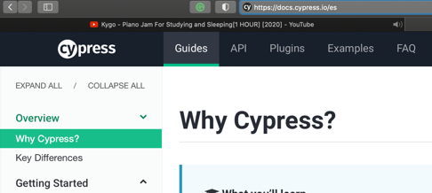 | Pass
2 | The site has an option to switch into Spanish language. |  |  | Fail
3 | The site involves the Spanish title ¿Por qué Cypress? |  |  | Fail
4 | User can change back to the English version of the site. |  |  | Pass
5
6
7
8
9
10
Comments:
Related Tests:
Author: Zdenko Mucina |  |  | Checker:

